Preview of entity transactions before normalization:

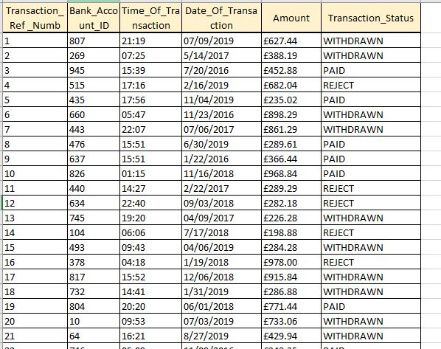

1NF, 2NF, 3NF

There is no violation on any of the normalization rules. Entity is already in 3NF.

PK is transaction_reference_number.

FK is bank_account_ID.

Preview of table after normalization:

